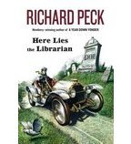
PeeWee

Jake

Col. Hazelrigg

Aunt Hat

Irene

